Idéer (Se mere I gammelt idédokument ):

Kosmetik
- Reducere samplings rate
- Frames around Graph on Live
- Live updates poorly
- Gridlines in profile graph
- Depth = 0 linie
- Use my reverse zoom icon
- Make “Reverse Wait (s)” field grey out when Reverse checkbox unchecked.
- Make “Writing Excel file…” message – “Cancel”
- Include the “Writing Excel file…” message and “Cancel” button in the close-down dialog.
- Channel data header ændres fra calibrated til e.g. (µM), ny header-linie hvis ændres
- Make app icon
- Allow shutdown if motor disconnected before shutdown.

Funktionalitet
- Make Instructions tab
- Live og Profiling grafer: individuelle akser
- Startup: scan all ports and test device on active
- Tillad ikke Record uden fil hvis denne skippes I startup.
- Integrate motor end stop
- Make reverse profile arrow.
- In the settings tab, make a grid with a header “Channels” with 8 rows. In each row display the hardware channel name (CH0, CH1 etc.) and a user-editable text field for the user channel name. Also in each line, make a drop-down selection list to set the channel’s voltage range.
- When no signal instrument is found, show a single channel displaying a sinewave of 0.1 Hz with an amplitude of 0.1V around 0V and display a text in red “No signals connected” on the display.
- Lave speciel Event-tabel? På Overview-tab

Større ting:
- Lav apparatgenkendelse automatisk
- Portere til miljø, hvor jeg selv kan justere kosmetik. ChatGPT: ”Visual Studio has a resource editor for Win32 dialog layouts, but Tasker would need some restructuring to use it. The custom signal graph would still be drawn in code. Alternatively, moving the interface to Qt would let you use Qt Designer to adjust forms visually, though that would be a larger change.”
- Designe sekvens-afvikling

Tests
Slet kalibring midt i og se om profildata afspejler det. Lav en, slet, kør uden, lav ny, kør, slet, kør.

Done:

Kosmetik
- Numeriske felter, tilpas bredde.
- Afrund meget små værdier (f.eks. 6.537E-17)
- Remove text “Stepped scan signals…” text from the Profiling tab
- The graph area of the graph on Calibration tab colors darker grey from the actual time and then onward until you leave the tab. When you go to the Calibration tab again, the area is gone, but starts displaying again from actual time onward. The grey area also resets when you zoom on the graph.
- Move the “MoCo ASCII command” and “Controller response” texts and associated fields and buttons from the Profiling tab to the Advanced Motor dialog
- Remove the field that displays the motor status from the Profiling tab
- The legend on the lower graph on the Calibration tab blinks, perhaps because legend text and check boxes are redrawn.

Funktionalitet
- Zoom-tekst ved spørgsmålstegn
- Slette kalibreringer
- Make a checkbox labelled “Sound” next to the “End” field, and if checked, play a ding sound after each profiling step and the Windows Exclamation sound a single time when a profiling run is finished and three times within a second after finishing a multi-cycle run.
- On the Profiling tab: make a ”Reverse” checkbox next to a ”Reverse wait (s)” field. Next to that, make a set of three Radiobuttons labelled “No overshoot”, “Keep overshoot”, and “Reverse overshoot”. If Reverse is un-checked, the radiobuttons should be greyed out. If Reverse is checked, a profiling run from starting from “End” to “Start” is performed after the time in “Reverse Wait (s)” field is elapsed before making the movement to “Safe”. During the run, for each step, the overshoot function is either not used, used in the reverse direction, or kept in the same direction as indicated by the radiobutton setting. Write the settings to the ini-file.
- Start recording som default
- Live:
  - Zoom
    - both axes med drag a rectangle down-right, unzoom m opposite. To last zoom m right-click. Retain 10 settings in memory. Small collapsable inset for navigation.
- Hvad med flere profiler? Lave valgbar visning
- While pausing, allow changes to parameters Start, Stop, Step, Wait, Profile label and resume profiling with the new parameters. If the profiling is paused during a profiling run and the profile label is modified while pausing, associate the modified label to the profile in progress.
- Define “full channel name” as a text consisting of (hardware channel name)+” – “ +(user channel name). Use full channel name in the legends on the graphs on the Profiling tab and Signals tab.
- Lav underfolder med bruger-navn og dirriger .txt output dertil.
- Gem til Excel med brugernavn i hovedfolder ved 1) app lukning eller 2) tryk på ”Excel-knap”
  - Fane ”Profiles”
  - Fane ”Calibrations”
  - Fane ”Events”
  - Fane ”Settings”
  - …?
  - Mine udtræksfaneblade
- Plotte profiledata på Live – selectable for hver channel.
- If “Make Excel” is pressed more than one time make dialog with text “Excel file already made” and buttons “Overwrite” and “New file”. The “Overwrite” button overwrites the existing Excel file, the “New file” button makes a new file where “_” and an incrementing number starting at 2 is appended to the name.
- Pressing the Esc key should stop motor movement. If the motor moves due to a press on the “Go to” button, movement is stopped. If the motor moves due to a profiling activity, the “Pause” state is activated to allow continuation of the (multicycle) profile run.
- Show position on Live

Større ting:
- …

Tasker user instructions

Installation
- A/D converter:
  - download og installer MCC DAQ Software/Universal Library
  - kør Instacal (kræver tilladelse til ændring af registry eller restart) Portér til andet

Advanced motor settings
The Advanced button on the Settings page allows the user to change motor settings, e.g. velocity. If at some point the set of values seems dysfunctional, here is a set that seems to work that can be reverted to:
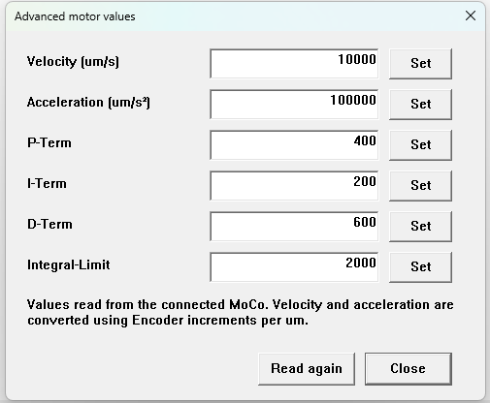

Excel Export
If the user puts a file with the name Tasker_template.xlsx in the data folder, it will be used as template for data output. Tasker will save Live and Profiling data as well as Calibration data and Comments and if the user has made suitable existing tabs in the template they can be used subsequently for processing the data. If the template does not exist, Tasker will use one located in the Tasker exe folder.

Versions
1.26:

